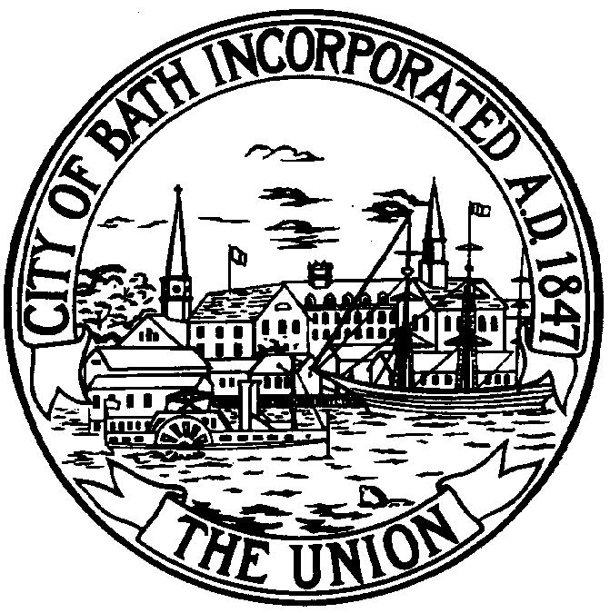
CITY OF BATH, MAINE CODES ENFORCEMENT OFFICE
City Hall 55 Front Street Phone (207) 443-8334
Bath, Me 04530 FAX (207) 443-8337
www.cityofbath.com TDD (207) 443-8368

MOLD

Molds are naturally-occurring organisms that can be found everywhere, both indoors and out. Humans do not live in a mold-free environment, nor would we want to. Molds are a necessary part of our natural environment. Problems occur, however, when conditions indoors allow for excessive mold growth. The primary culprit for this excessive growth is excess moisture. Maintaining your home or building to prevent excess moisture and properly fixing moisture problems when they do occur are the keys to preventing both building damage as well as health problems associated with mold. In old and/or poorly insulated buildings, it’s not uncommon to have mold form on cold surfaces such as exterior walls. When warm, moist indoor air contacts a surface that’s cooler than it, condensation can occur, creating moisture that enables mold to grow. Things that can exacerbate moisture problems are unvented clothes dryers, broken or nonexistent bathroom fans, and building/plumbing leaks. Mold affects different people differently. An amount of mold that has no ill health effects on one person can make another person sick. Due to these variables, there are no quantifiable standards for how much mold is too much. If a mold problem exists in a building, resolving it is a matter between the building owner and occupant(s). Below are some resources for people dealing with these sorts of issues.

Pine Tree Legal Assistance www.ptla.org
207-622-4731 Augusta 207-774-8211 Portland
A free legal assistance program for low income Maine residents
The Legal Library section of their website has a good section on housing issues.

Maine Attorney General’s Office www.maine.gov
207-626-8800 They have a good handout on their website called Consumer Rights in Maine, that has a chapter on rental housing.

The Maine Department of Environmental Protection www.maine.gov\dep
207-287-7688 Put “mold” in the search browser and there will be several choices with lots of information on mold.

The Maine Center for Disease Control www.maine.gov\dhhs
1-888-821-5821 Put “mold” in the search browser and there will be several choices with lots of information on mold.

The Federal CDC www.cdc.gov\mold
1-800-232-4636 The site has lots of good information on mold.

2-20-13

